Grid Configuration Using JSON

# Hub_config.json

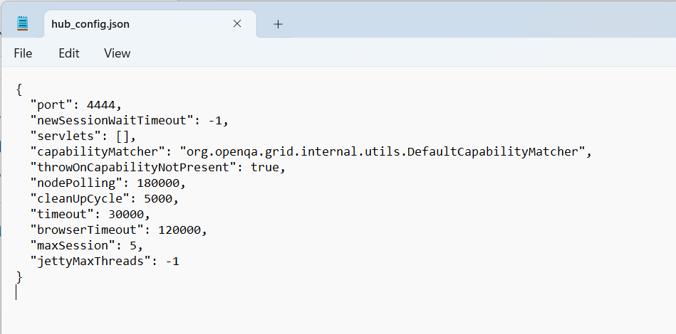

Java -jar selenium-server-standalone-3.141.59.jar -role hub -hubConfig

# Hub_config.json

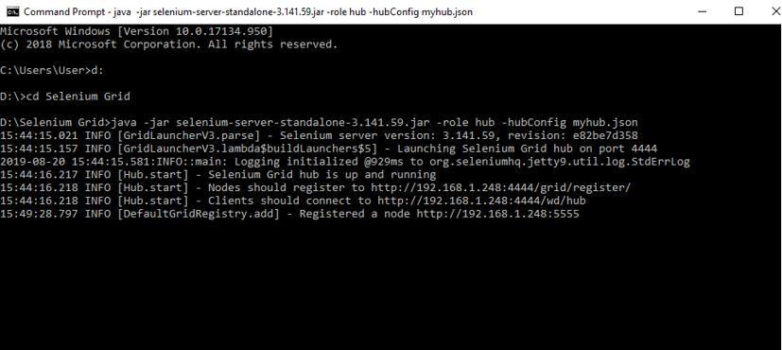

Mynodes.json

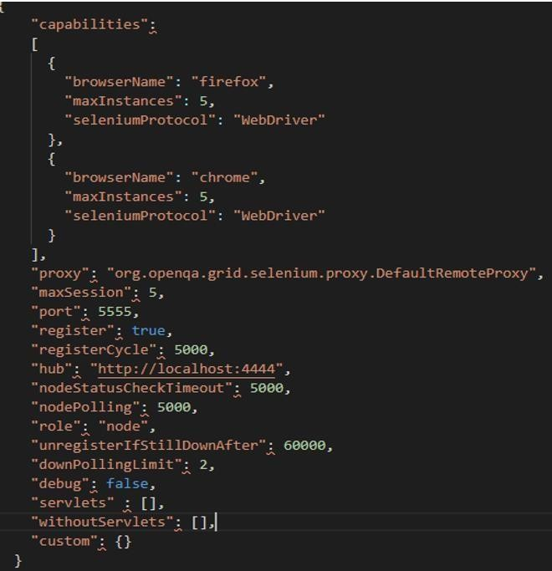

java -Dwebdriver.gecko.driver="geckodriver.exe" - Dwebdriver.chrome.driver="chromedriver.exe" -jar selenium-server-

standalone-3.141.59.jar -role node -nodeConfig mynodes.json

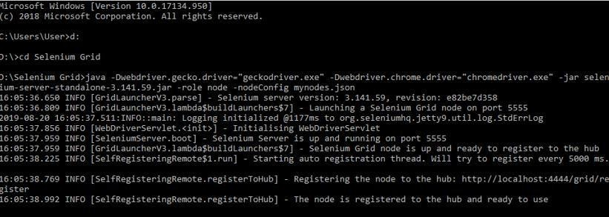

http://localhost:4444/grid/console

